Louisiana Main Street Recovery Grant Program –Act 497 Portal User Guide
CREATING AN ACCOUNT AND SUBMITTING AN APPLICATION
AS OF 09/14/2022

https://la-treasurer.viewpointcloud.com/

Table of Contents
How to Setup a Louisiana MSRP Account for Your Business 3
How to Find the MSRP Portal 3
How to Gain Access 4
How to Login 5
Navigation of “My Account” Upon Successful Log In 6
Apply Online 11
How to Fill Out an Application for the Louisiana Main Street Recovery Program 12
Step 1: Confirm your contact information 12
Step 2: Main Street Recovery Program - Act 410/497 Program Type 13
Step 3: Business Applicant Information 14
Step 4: Industry Category 17
Step 5: Business Owner 18
Step 6: Eligibility Information 18
Step 7: FOR LOGGERS RELIEF PROGRAM 20
Step 8: Other Sources of COVID-19 Related Funding 21
Step 9: 2020 Revenue Loss Calculation entered by Applicant 23
Step 10: Federal Funding Certification and Agreement to Hold Harmless and Indemnify 24
Step 11: Attachments 26
Confirmation of Your Submission 27
How to Fill Out an Application for the Louisiana Main Street Recovery Program Once You Have Already Made an OpenGov Account 28
Check the Status of Your Application 30
How to Communicate With Your Application Reviewer 32
How to Upload Additional Attachments to Your Application 34

How to Setup a Louisiana MSRP Account for Your Business
The individual at the Business who establishes access to the Portal is considered to be the Primary Contact or Authorized Representative. This individual is the main point of contact for the Louisiana Main Street Recovery Grant Program.

Throughout the portal, you will see a “?” highlighting that help is available on a field. Hover over the “?” to see the help text.
Throughout the portal, all fields with an “*” are required fields in order to move forward.

How to Find the MSRP Portal
From your web browser, go to https://la-treasurer.viewpointcloud.com/ This is the link to the public informational website about the Louisiana Main Street Recovery Grant Program. You will see this screen:
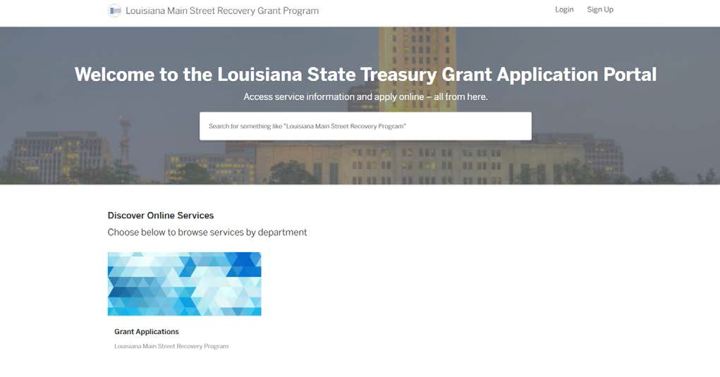
You will click on the “Act 410 Grant Application” and you will see “Louisiana Main Street Recovery Program” (see screen below).

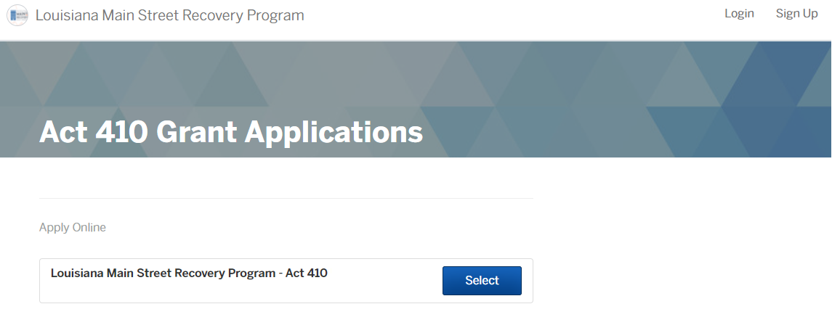
Click “Select” and then “Apply Online” (see screen below).
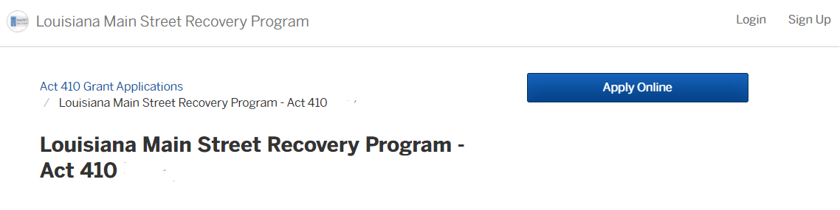

How to Gain Access
To create an account, click the “Sign up” button in the top right corner. From this screen, you will have the option to “Create a Viewpoint ID” on the left. To create an ID, click “Sign Up using Secure Portal” button (see screen below). This will allow you to create a user ID using your email address and to create a password.
Note: If you previously created a Viewpoint ID using an email address, you will be unable to create a new Viewpoint ID using the same email address. If you forgot your password, use the ‘Don’t Remember Your Password’ button to reset your password.
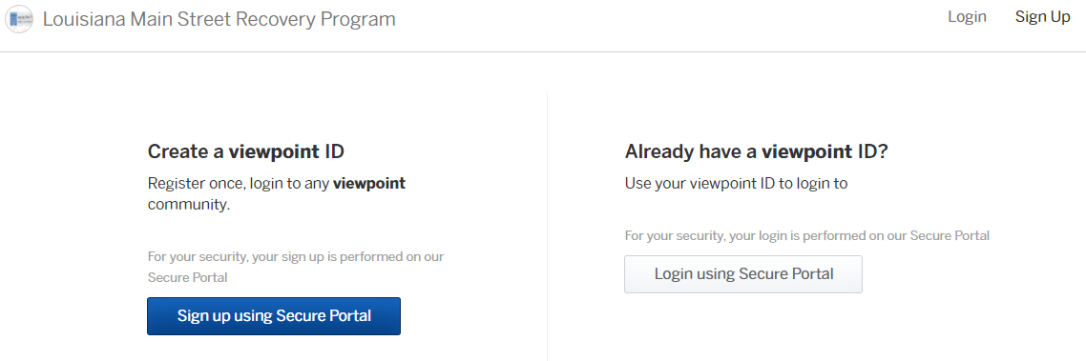

How to Login
Once you create your user name and password, you will be able to log in using this screen:
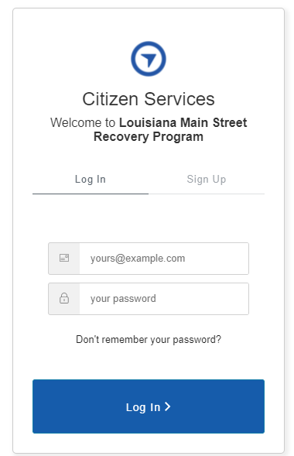
To login to your account, click “Login using Secure Portal”. Enter the email address and password you used to set up your account (see screen above). Click “Log In”.

Navigation of “My Account” Upon Successful Log In
- To access your account, select “My Account” in the top right hand corner.

- Dashboard
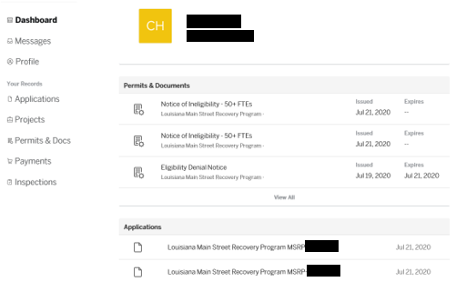
  - Permits & Documents: Can be printed out for your record by selecting the document.
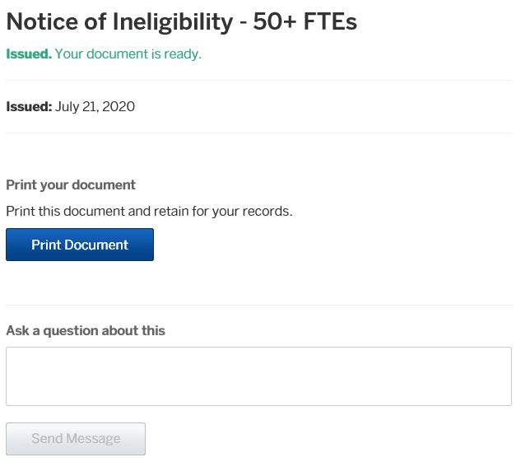
      - To view documents or notices that you have received, click on the “Notice” document on the right column. From there, you will be taken to the screen below. To view or print the document, select “Print Document”
      - To ask a question about this document, type in your question in the “Ask a question about this” box and click “Send Message.” This message will go to the application reviewer and they will be able to explain this document that you have been issued.
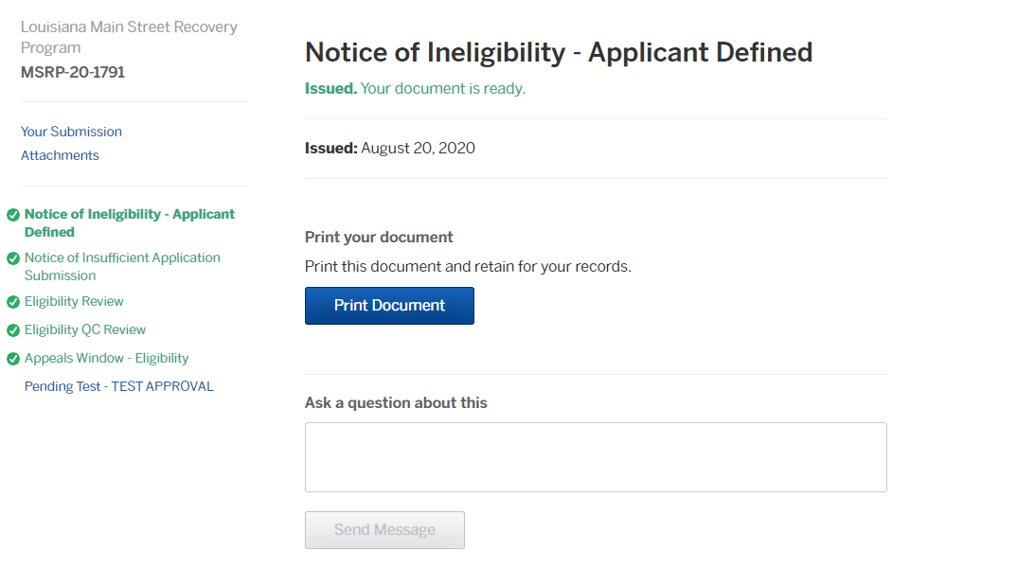

  - Applications: Displays applications and submission date(s).
      - This section displays any applications that have been submitted or that are incomplete.
      - NOTE: The application that has been submitted to the LAMSRP Program will have “ACTIVE” as the status. The application that has a status of “DRAFT” has NOT been submitted (see screen below).
      - To finish a draft of an application, click on the application with the status as “Draft” and continue filling out the application.
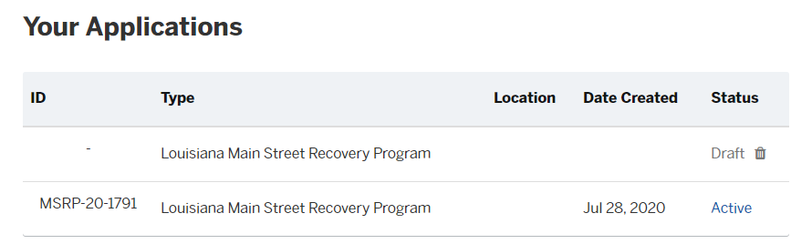
- Messages: Allows the applicant to view any messages sent to and received from the Program related to the application(s) submitted. If you have messaged your application reviewer, you will see their response in this section. (See screen below).

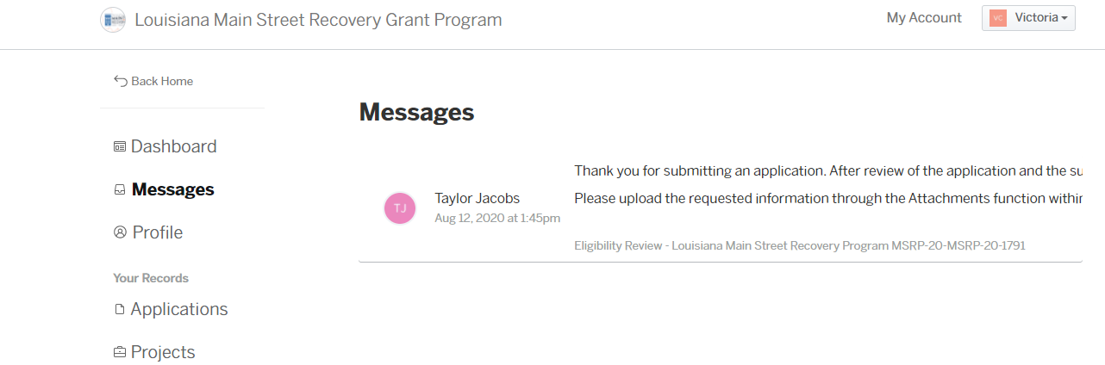

  - If you would like to message your application reviewer, you can do so by selecting the “Applications” tab on the left side under the “Your Records” portion of the dashboard (see screen below).
  - You will then click on your submitted application. Note: If you have any applications that are drafts, you must click the application that says “Active” in order to message your application reviewer (see screen below).

  - To message your application reviewer, select the application on your Dashboard and you will be taken to the Your Submission page. On the left hand column, select the current step in progress (blue).

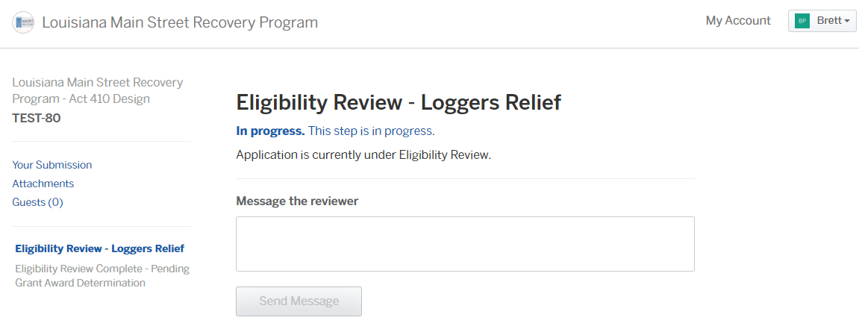
  - On this screen, you will see the “Status” of your application. You can also message your application reviewer. To do this, type in your message in the “Message the Reviewer” box and click “Send Message.”
  - The application reviewer will be alerted of your message and will be able to communicate with you about your application.

- Profile: Edits can be made to basic account information.
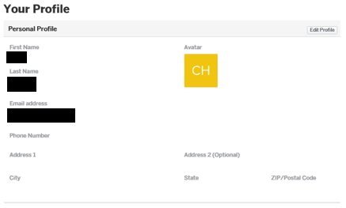
  - To view your information, update an email address, address, or phone number, you can do so by clicking on the “Profile” section. This will take you to the screen above.
  - Once you have arrived at this screen (see screen above), you can edit your information, update your email address, address, phone number or reset your password. To do this, you must click on the “Edit Profile” button on the upper right side of the profile (see the blue rectangle above).
  - To edit your personal information (name, address, phone number or email address), you can do so here. Once you enter your correct information, click “Save” (see screen below.)
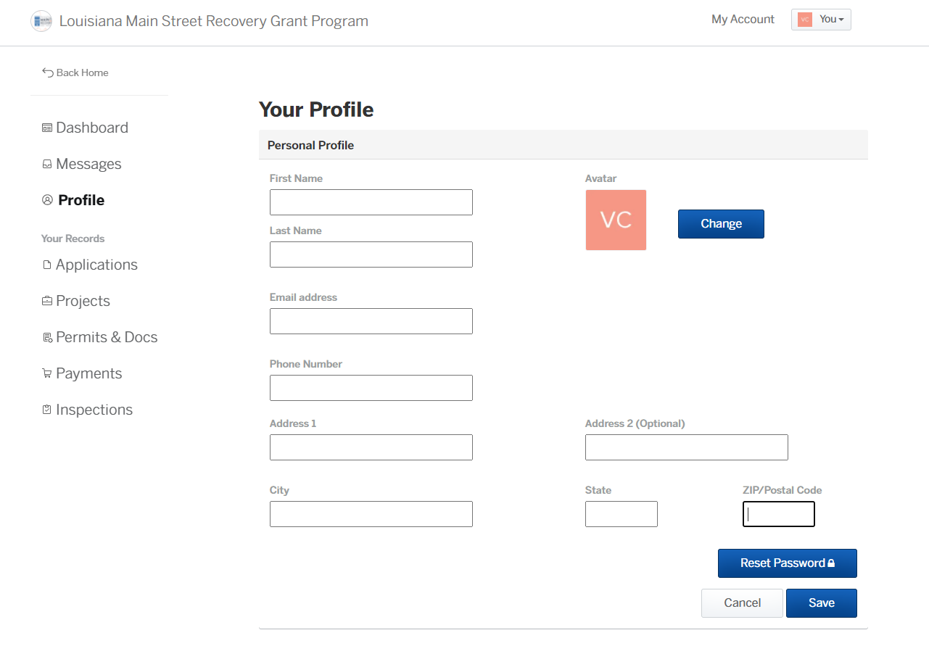
  - To change your password, select “Reset Password.” You will be sent an email to the email address you have provided to change your password.

- Your Records – Applications: Displays all active and draft applications and the date created.

Apply Online
- To Apply online, visit https://la-treasurer.viewpointcloud.com/
- Select “Main Street Recovery Program – Act 410 Program Type” (see screen below.)
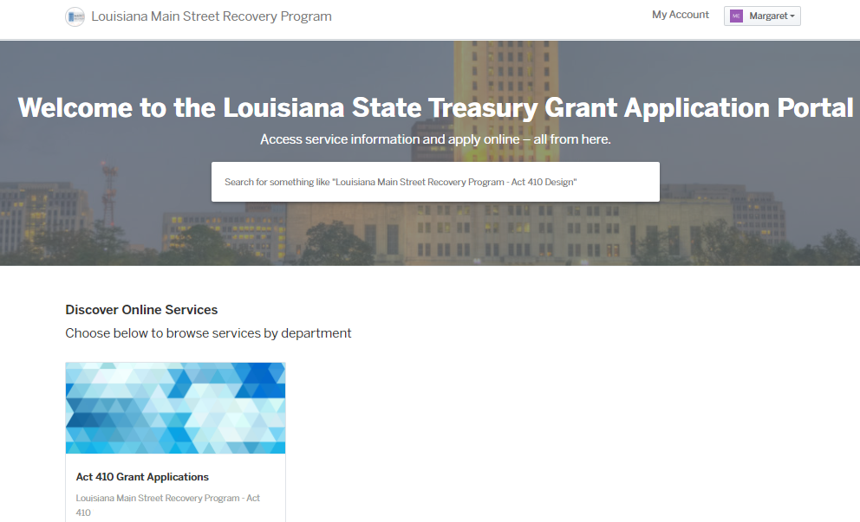
- Select Apply Online to begin the application (see screen below).
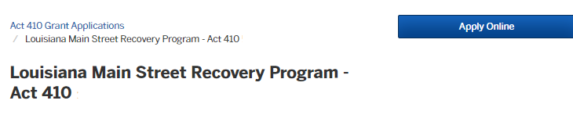

How to Fill Out an Application for the Louisiana Main Street Recovery Program

Step 1: Confirm your contact information
- Please ensure that your contact information is up to date.
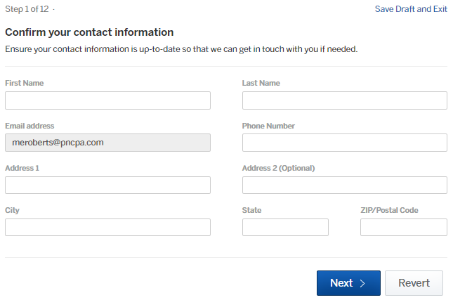
- Enter the primary contact information for the application. Once you have submitted an application, you can update contact information.

Step 2: Main Street Recovery Program - Act 410/497 Program Type
During the 2022 Regular Session of the Louisiana Legislature, the legislature passed, and Governor John Bel Edwards enacted, Act 497 establishing the Louisiana Main Street Recovery Program (“Program”). Act 497 is an extension of Act 410 which was passed by the Legislature in the 2021 Regular Session. The purpose of this program, which is managed by the Louisiana Department of Treasury (“Treasury”), is to provide economic support in the form of grants to Timber Harvesting or Timber Hauling Businesses headquartered in Louisiana impacted by the COVID-19 pandemic.
- The Eligibility Requirements for these Programs are different. Please select the appropriate Grant Program Application Type that aligns to your Applicant Business Industry Designation.

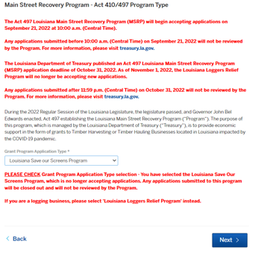

Step 3: Business Applicant Information
Note: For applicants to the Save Our Screens Program, any reference within the application to "Business" refers to the individual movie theater location for which you are applying.
- Enter the following information into the appropriate fields on this screen.
  - Business Legal Name
    - As registered with Louisiana Secretary of State. If the Business is not registered with the Secretary of State, enter the Business Name as it appears on the income tax return.
  - DBA or Tradename (if applicable)
  - Business Type
  - Business Tax Return Form
  - Social Security Number (SSN), if applicable
  - Federal Taxpayer ID Number (EIN), if applicable
  - Does the Business report income taxes based on a year-end of December 31st?
  - Date of Formation/Creation of the business
  - Business Phone Number
  - Number of Full-Time Equivalent Employees (as of March 1, 2020)
    - The simple method that may be used for calculating the number of ‘Full-time equivalent employees” is to assign a 1.0 for employees who work 40 hours or more per week and .5 for employees who work fewer than 40 hours per week. A more detailed calculation method can be found on the program’s Frequently Asked Questions page at https://www.louisianamainstreet.com/faq/.
  - Business Physical Address
    - Business Physical Street Address
    - Business Physical City
    - Business Physical State
    - Business Physical Zip Code
      - Enter the 5 digit zip code.
    - Business Physical Parish
  - Business Mailing Address
    - Note: Any payments for approved grant awards will be mailed to the Business Mailing Address provided below.
    - Business Mailing Street Address
    - Business Mailing City
    - Business Mailing State
    - Business Mailing Zip
  - Additional Business Information
    - LA Secretary of State Charter Number
      - LA Secretary of State Charter # can be found by clicking “Search for Louisiana Business Filings” on the LA Secretary of State website at: https://sos.la.gov/. Sole Proprietors may enter “N/A” if the Business is not registred with the LA Secretary of State.
    - LA Department of Revenue Account #
      - The LA Department of Revenue Account Number for the Business can be found on the first page of your Louisiana income tax return, Louisiana sales tax return, or Louisiana employer withholding form. The format for the account # is #######-001 for Partnerships, LLCs, and Corporations. Please enter first 7 digits prior to -001. For Sole Proprietors, enter your SSN (###-##-####).
    - LA Workforce Commission Employer ID #
      - The LA Workforce Commision Employer ID # is for companies that pay unemployment taxes. To find this, you may look on the company’s tax return.
      - If your company does NOT pay unemployment taxes or insurnace, you may enter “N/A.”
      - Sole Proprietors may enter “N/A” if the business is not registered with the LA Workforce Commission.

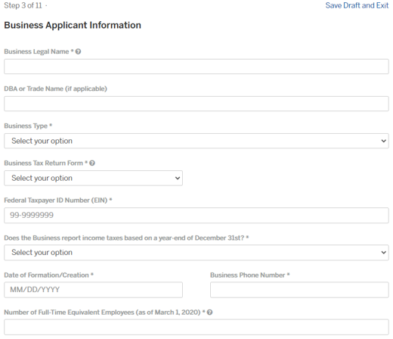
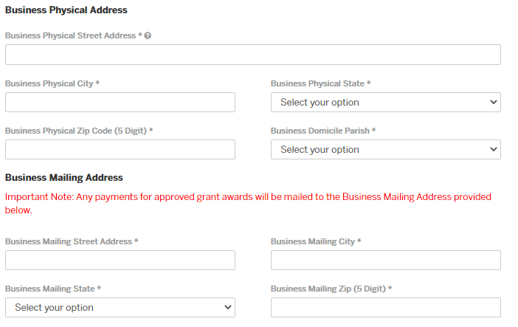
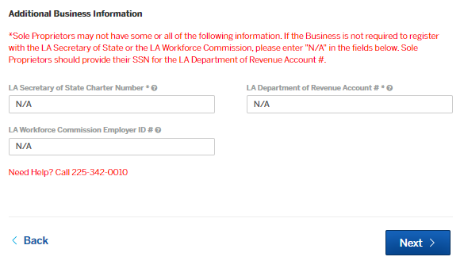

Step 4: Industry Category
Please enter the appropriate Principal Business Activity Code as it appears on the Applicant Business' Federal Tax Return. The IRS Principal Business Activity Codes can be found on the Applicant Business Tax Return.

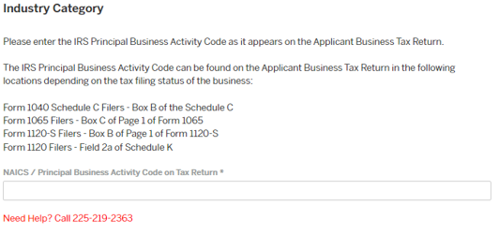

Step 5: Business Owner
Please provide ownership information as reflected on the Business Tax Return Forms.
- Click “Add Business Owners”, fill out the form dialogue box (shown below), and upload a copy of the owner driver’s license, if available. Click button again to add another owner until all owners are listed.
  - Note: Social Security Number (SSN) and Employee Identification Number (EIN) are both required.
    - If the Owner Type is Entity, please enter SSN of 000-00-0000.
    - If the Owner Type is Individual and the business does not have an EIN, please enter an EIN as 00-0000000.
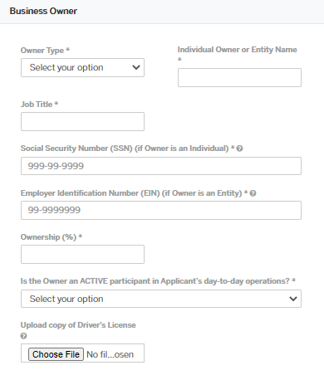

Step 6: Eligibility Information
Answer each question appropriately. Take note that if you answer “Yes” to your tax filings, you will need to upload your tax documentation. The following clarifications are provided for the eligibility questions (Note: This is not a complete list of the eligibility questions.)
- Did the Business have a physical and active operation in Louisiana as of March 1, 2020?
- Did the business have 50 or fewer full-time equivalent employees as of March 1, 2020?
  - The simple method that may be used for calculating the number of ‘Full-time equivalent employees” is to assign a 1.0 for employees who work 40 hours or more per week and .5 for employees who work fewer than 40 hours per week. A more detailed calculation method can be found on the program Frequently Asked Questions page at https://www.louisianamainstreet.com/faq/.
- Did the Business file Federal and Louisiana state taxes for BOTH 2019 and 2020 tax years?
  - If yes, you will be asked to upload a copy of both your filed 2019 and 2020 Federal Income Tax Returns for the Business.
  - If the Business is not required to file Louisiana state taxes at the entity level, this question will refer to the reporting of the Business at the individual level.
- Did the Business experience a loss of gross revenue for the period of January 1, 2020 through December 31, 2020, as compared to the gross revenue of the business during the same period in 2019?
- Is the Business in good standing with the Louisiana Secretary of State (if Applicable)?
  - If the Business is a Sole Proprietorship and NOT required to register with the Louisiana Secretary of State, select YES.
- Does the Business exist for the purpose of advancing partisan political activity?
- Does the Business directly lobby federal or state officials?
- Does the Business derive income from passive investments without active participation in the business operations?
  - “Passive Investments” as used in ACT 497 refers to income derived from passive activity as defined by the Internal Revenue Code Section 469.

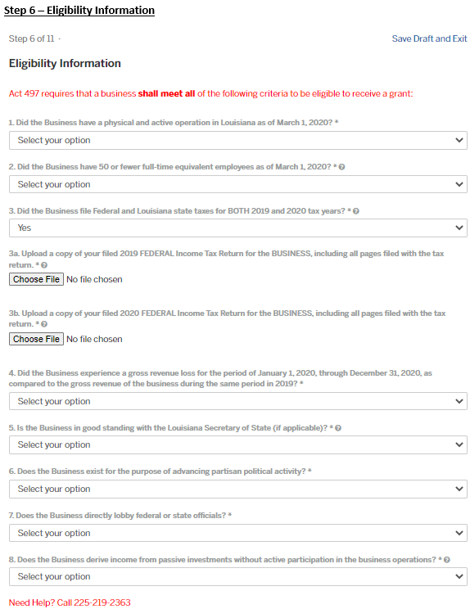

Step 7: FOR LOGGERS RELIEF PROGRAM
In addition to the Eligibility Criteria in the previous section, Act 497 requires that a timber harvesting or timber hauling business shall meet all of the following criteria to be eligible to receive a grant:
- Is the Business classified as one of the following IRS Principal Business Activity Codes: (a) 113000, 113110, 113210, 113310, or 115310? A business may also be classified as (b) 484110, 484120, 484200, or 484220.
- Is the Business headquartered in Louisiana?
- Is the Business a subsidiary of a business with more than 50 full-time equivalent (FTE) employees, part of a Larger Business Enterprise with more than 50 FTE employees, or owned by a business with more than 50 FTEs?

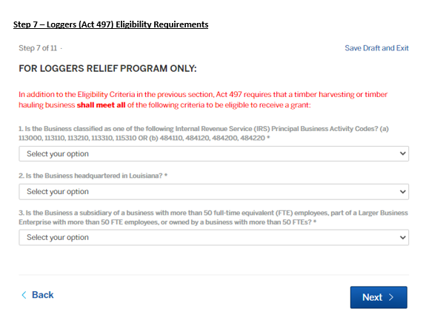

Step 8: Other Sources of COVID-19 Related Funding
Provide information about the funds you have received related to COVID-19, including ANY loans or loan advances received. Once the amounts are entered for each source, the Total Other COVID-19 Funds Received box will populate automatically with the totaled funds from those entered in the boxes above.
If the entity owner received funding on behalf of the business applying, please include the total amount received by the entity owner for the applicable source of funding. At the end of the application, upload documentation to support the amount of funds allocated to the business for which you are applying.

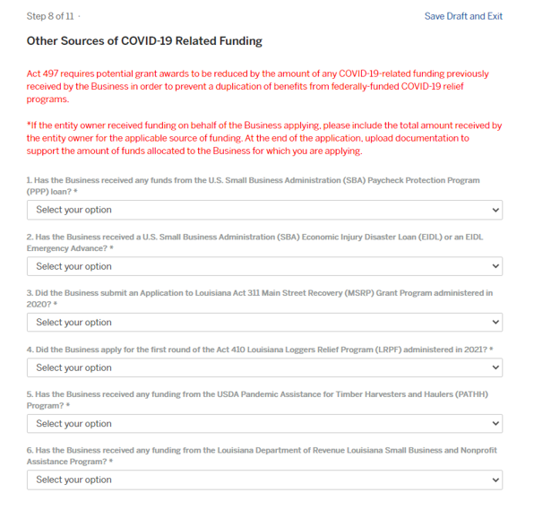

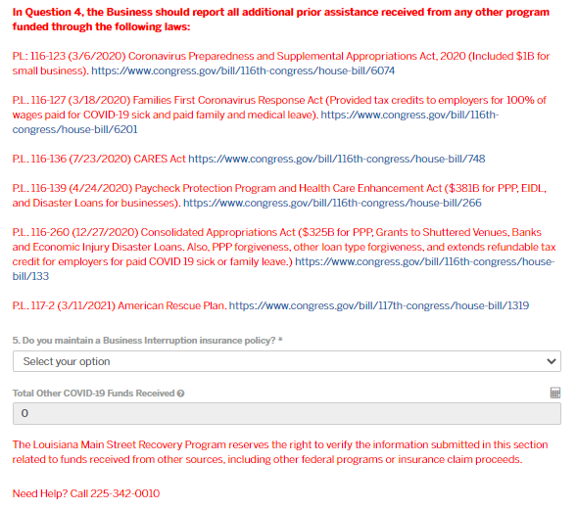

Step 9: 2020 Revenue Loss Calculation entered by Applicant
The Program is intended to provide grants to businesses that “experienced a loss of gross revenue for the period of January 1, 2020, through December 31, 2020, as compared to the gross revenue of the business during the same period in 2019” as outlined in La. R.S. 39:100.44.1(B)(4)."
Please enter the 2019 and 2020 Gross Receipts or Sales as reported on your Federal Tax Return Forms. Once the amounts are entered for each year, the Total Reduction in Business Revenue and Percentage Decrease in Business Revenue Year over Year (%) box will populate automatically.
- 2019 Total Business Gross Receipts or Sales, as appears on 2019 Business Tax Return.
- 2020 Total Business Gross Receipts or Sales, as appears on 2020 Business Tax Return.

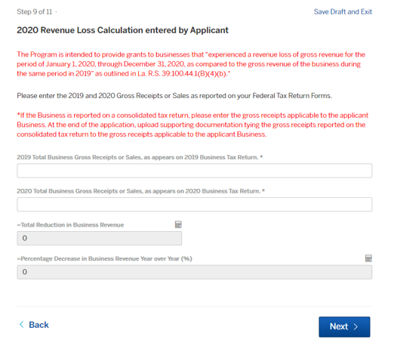

Step 10: Federal Funding Certification and Agreement to Hold Harmless and Indemnify
Review the information, select the certification checkbox, and enter the appropriate information into the Printed Name, Signature Date, and Authorized Representative Capacity boxes.

Important Note: This grant application must be completed by an Authorized Representative of the Business Applicant. By submitting this application, you must declare, under the penalty of perjury, that you are authorized to complete and sign the grant funds application on behalf of the Business Applicant.

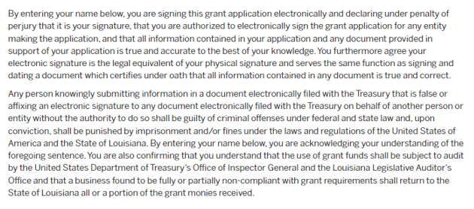
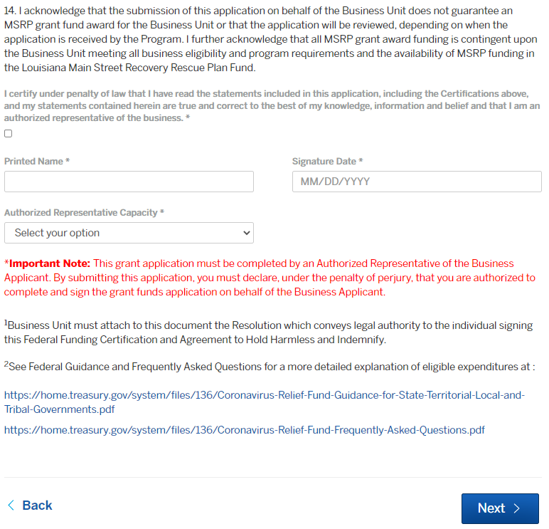

Step 11: Attachments
Include any additional files with your submission. Any box marked "Required" is required to submit your application. Please note the maximum allowed file size for any upload is 100 MB. If you have several documents that are larger than 100 MB, please review the instructions on how to consolidate multiple documents located in the Resource Center of the Louisiana Main Street Recovery Program website by visiting the following link https://www.louisianamainstreet.com/resource-center/.

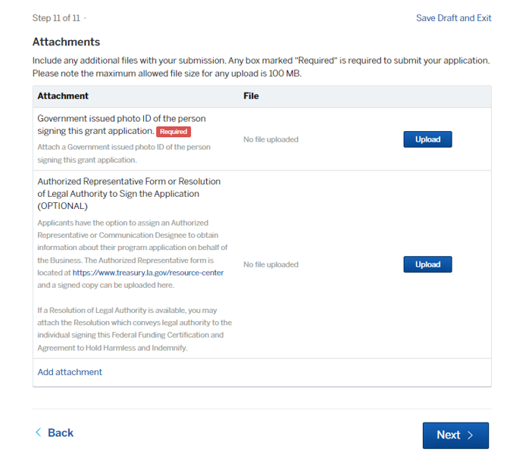

When adding an attachment, include a description of the document being uploaded.
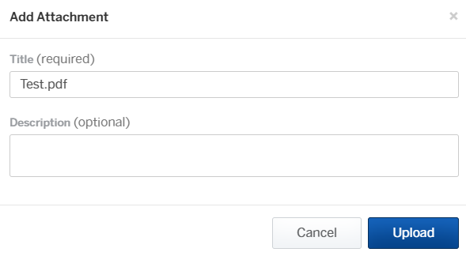

Confirmation of Your Submission
Please review all of your submitted information for completeness and accuracy. Click “Confirm and Submit” at the bottom of the page once you are ready to submit the application.
A confirmation email will be sent to the email on file.
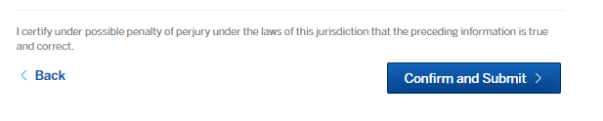

How to Fill Out an Application for the Louisiana Main Street Recovery Program Once You Have Already Made an OpenGov Account
Once you have created an OpenGov account, and you have not submitted an application right away or you would like to submit an additional application, you may do so once you log back in to the portal.
- To submit an application online, visit https://la-treasurer.viewpointcloud.com/. Select “Grant Applications: Louisiana Main Street Recovery Program” (see screen below).

- Click the “Select” button on the “Grant Applications” page (see screen below).
- Select “Apply Online” (see screen below).

- Select “Login using Secure Portal” and enter your OpenGov username and password that you have previously created.
- Once you have logged in, you can start the application. You will be directed to this screen to begin the application (see screen below).

- After you have finished confirming your contact information, click “Next” and continue the application. To review directions on how to complete the application, please visit page 12 of this guide.

Check the Status of Your Application
Once you have submitted an application, you may log back into the portal to check the status of your application. Once you are logged in, click on the “Applications” section of the Dashboard (see screen below).
The next screen will take you to any applications that you have already submitted, or were in the process of submitting. To view your application, click on the application with the status that reads “Active” (see screen below).

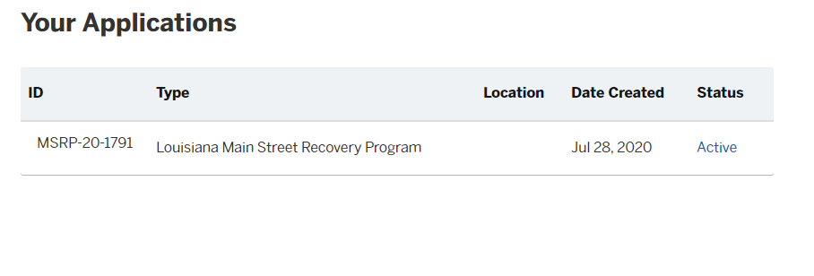
Click on the application, and you will see the status of the application on the left hand side of the dashboard (see screen below).
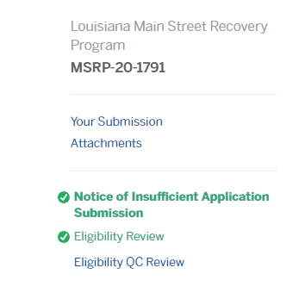
You will see a green checkmark indicating the status of your application as it is being reviewed.
To gain more understanding of the status of your application listed, please review the chart below.
STATUS | DESCRIPTION
Eligibility Review  Eligibility QC Review | The Program is working to verify that your business meets the eligibility requirements of the program. Stay tuned and keep checking the portal for updates!
Eligibility Review Complete - Pending Application Grant Award Review | We have determined that your business meets the eligibility requirements. Next step: your grant award will be calculated.
Appeals Window - Eligibility | You have received a Notice of Ineligibility. If you disagree with the Program's eligibility determination, you may appeal using the instructions in your notice. This status means you are within the timeline that allows for appeals.
Grant Award Determination Review | We have verified your eligibility! Your grant award is being calculated based on the information you submitted.
Appeals Window - Grant Award Determination. | You have received a Grant Award Notice. If you disagree with your grant award, you may appeal using the instructions in your notice. This status means you are within the timeline that allows for appeals.
Grant Award Funding - Pending Approval  Grant Award Funding | Great news! Your application is currently being processed for payment!

How to Communicate With Your Application Reviewer

Send a Message to the Application Reviewer
Once you have completed your application, you can communication with your application reviewer to check the status of the application, or answer any questions the reviewer may have.
- To do this, log in to your account and click on the “Applications” section of the dashboard (see screen below).
Once you have navigated to your applications, click on the application that you would like to review. (See screen below).
Once you have clicked on the application, you will be able to check the status of your application (see section above), and message your application reviewer.
- To send a message your application reviewer, select the step you would like to leave a message on in the left hand column. The completed steps will be highlighted green, the current step in progress is highlighted blue. It is best practice to leave new messages on the step in progress (blue) to ensure the current reviewer sees your message. Type your question into the “Ask a Question about this” box (see screen below). Once you have typed in your message in the box, click “Send Message.” This will post your message to the selected step and notify the reviewer.
Check Your Messages
If an application reviewer has a question, they can message you in the portal. To check these messages, log in to your account. Once you have logged in, you will see a “Messages” section of your dashboard (see screen below).
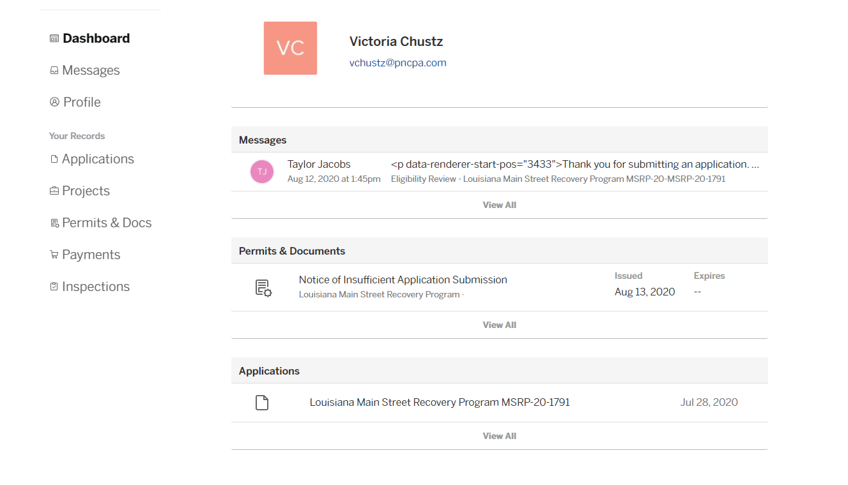
You will be able to communication to your application reviewer within the portal through this message function. You can review your messages by clicking the “Messages” section of the dashboard.

How to Upload Additional Attachments to Your Application
You may be required to upload additional documentation to your application once submitted.
- Navigate to the “Your Records – Applications” screen on your Account (see screen below).
- Select the Application for which you would like to upload an attachment.

- Once you are brought to your submitted applications page, click on the submitted application.
- You will see an “Attachments” section on the dashboard of your application (see screen below).

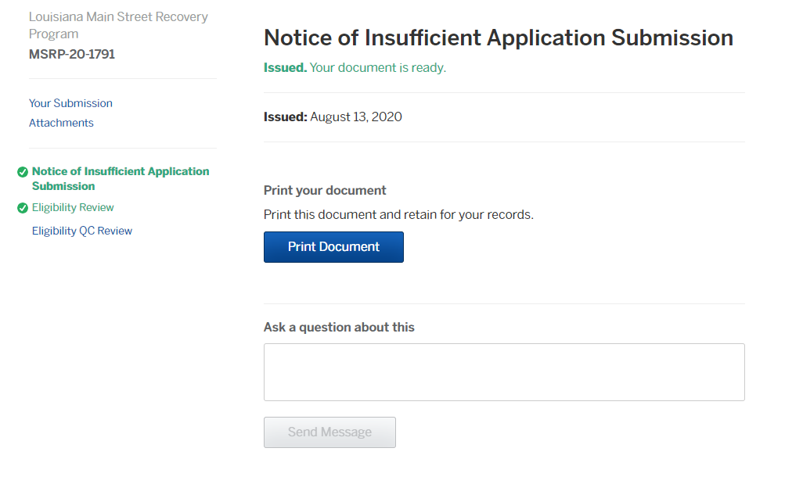

- Click on the “Attachments” section of the application and you will be able to review any attachments that you previously have submitted (see screen below).

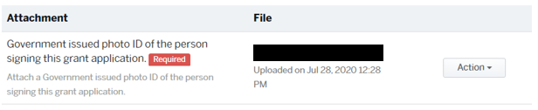

- You may review or replace any attachments that you have previously uploaded by clicking the “Action” button.
- To upload any new attachments, click on the “Add Attachment” button at the bottom of the screen (see screen below).
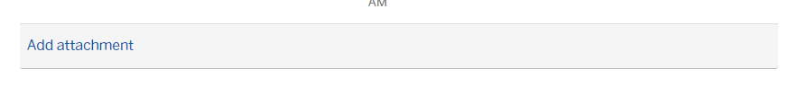
- You may title the attachment and add a brief description of the attachment that is being uploaded. Once you have chosen your file, click “Upload.”

